East Kilbride Old Parish Church
Scottish Charity No: SC000609

www.ekopc.org.uk

How to Join our Zoom Coffee Morning on Thursdays

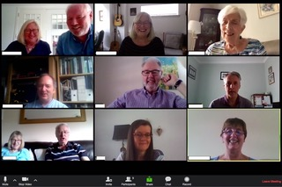

- Download Zoom
2. Register with a user name & password
3. Open & sign in to Zoom
4. Click on ‘Join a Meeting’
5. Enter the Meeting ID number which is: 820-1455-4693

6. Join in, checking video and microphone are active.

Don’t worry if you have problems on the day – we’ll help you work it
out through a Helpline number which will be shown on the website.
And then, once you are under way, you’ll find it’s a doddle!

