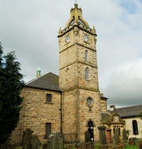
East Kilbride Old Parish Church
Use of Halls/Rooms

This form is intended for applications for occasional use of our halls or rooms for small meetings e.g. Team Meetings or informal discussions. The purpose is to ensure compliance with the relevant Covid restrictions.
The following are the general rules at the moment –
- Requests to be made to the church office before the meeting
- Someone to take responsibility for all the Covid protocols
- Face coverings to be worn
- Hand sanitising
- Record of attendees maintained by the organiser

Person Responsible: ____________________________________________

Tel no: ________________ e-mail address__________________________

Hall/Room Requested ___________________________________________

Details of Group ________________________________________________

Date/Time Requested ___________________________________________

I accept responsibility on behalf of the group for compliance with all Covid protocols and restrictions.

………………………………………………………. Date …………………………
Signature

Please email or deliver this to Louise at the Church Office ekopc.office@btconnect.com

Sept 2021

